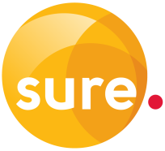

Application for

Talk Away

Talk Away gives you 10% discount on three international telephone numbers.

Please complete the blank fields fully.

|  |  |
| --- | --- |
| Enter number you would like to qualify for Talk Away (including full country and area codes) | e.g. 0044 1234 654321 |
| Number 1 |  |
| Number 2 |  |
| Number 3 |  |
| Contact Email address |  |
| Contact telephone number |  |
| Telephone account number |  |
| Signature |  |
| Name |  |
| Date |  |

|  |  |
| --- | --- |
| For official use |  |
| Actioned | Date: |
| AN number: |  |